**Real-Time Financial Transaction Processing**

**Objective:** To design and implement real-time financial transaction data processing that detects potential fraudulent activities, and provides actionable insights through analytics and visualizations.

**Source:** Azure event hub SDK to interact with event hub and to generate and send real time transactions data to event hub.

**Tools Used and Deliverables:**

|  |  |
| --- | --- |
| **Tools Used:** | **Deliverables:** |
| Azure Event Hub SDK | To generate and send real time transactions data to event hub |
| Azure Event Hub | To Ingest real time data |
| Azure Stream Analytics | To process real time transactions and detect fradulent activity |
| Azure Blob storage | To store the stream analytics output |
| Power BI | To visualize transcations data |

**Steps to follow:**

1. Set up Azure event hub to ingest real time data from SDK :

* Create a eventhub namespace and a event hub

1. Set up Azure event hub SDK to generate real time transactions data:

* Install necessary libraries

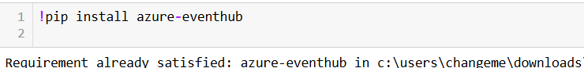

* Set up the python code to generate and send data to event hub

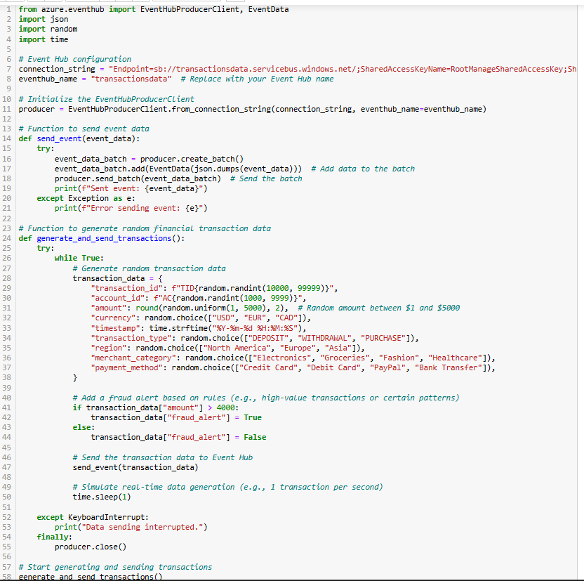

* Run the above code and see the generated real time transactions data: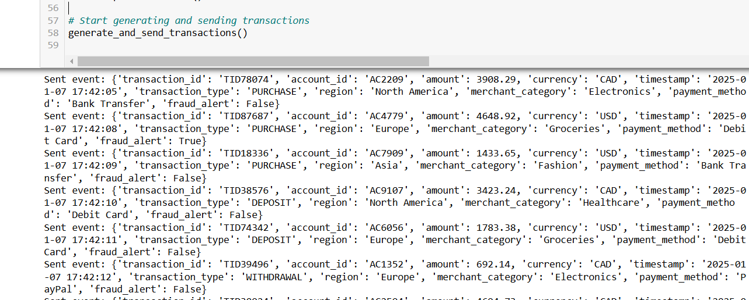
* Event hub will receive real time data as shown below:

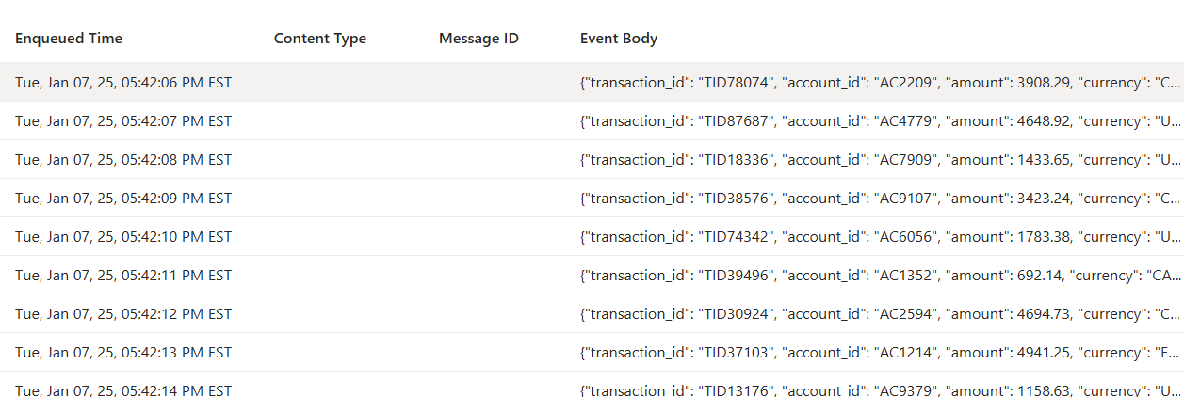

1. Set up Azure blob storage to store the processed data from stream analytics:

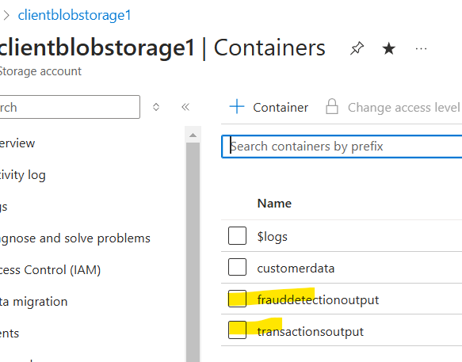

1. Set up Azure stream analytics to Process real time data ingested using event hub and detect fradulent activity:

* Input: Event Hub
* Output: Blob storage containers
* Query 1: To perform some aggregations on transactions data

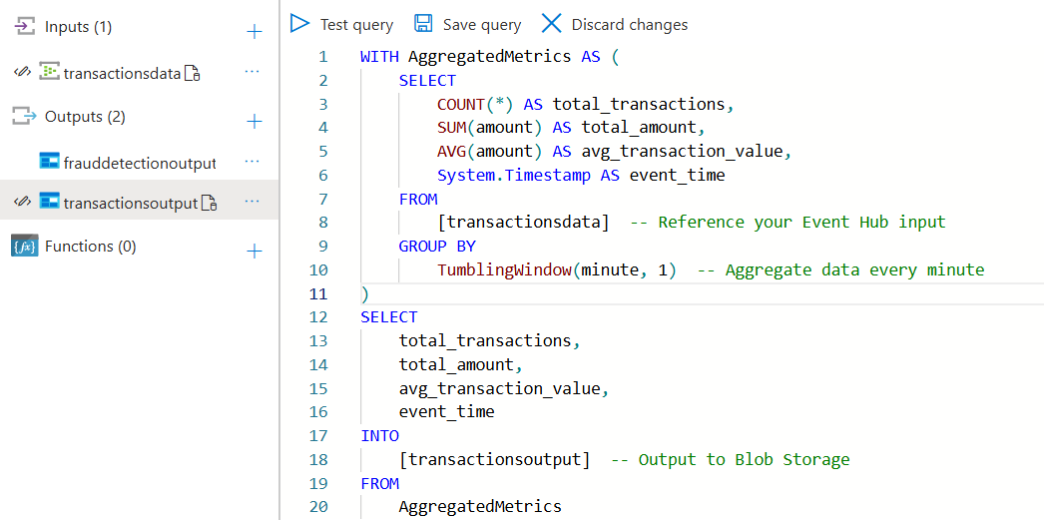

* Input preview: 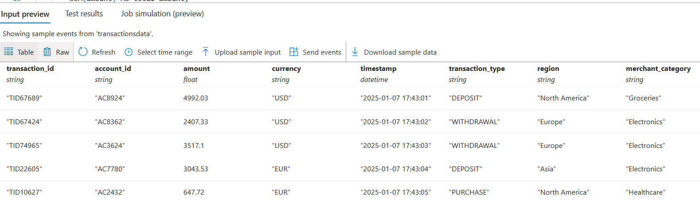
* Test the query and save it:

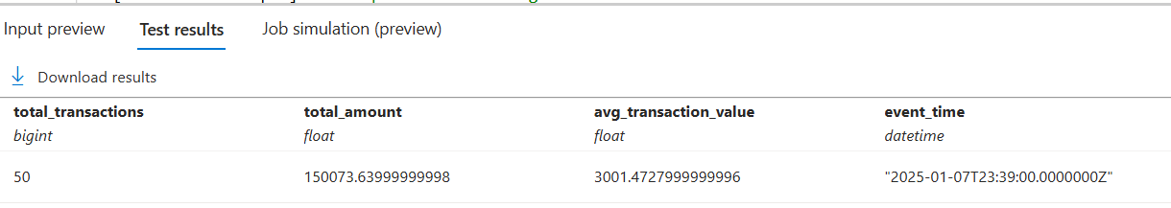

* Start the job: the event hub ingests the data, followed by stream analytics processing and loading the data into blob conatiner

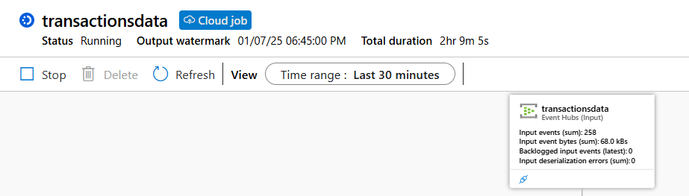

* Data loaded into Containers:

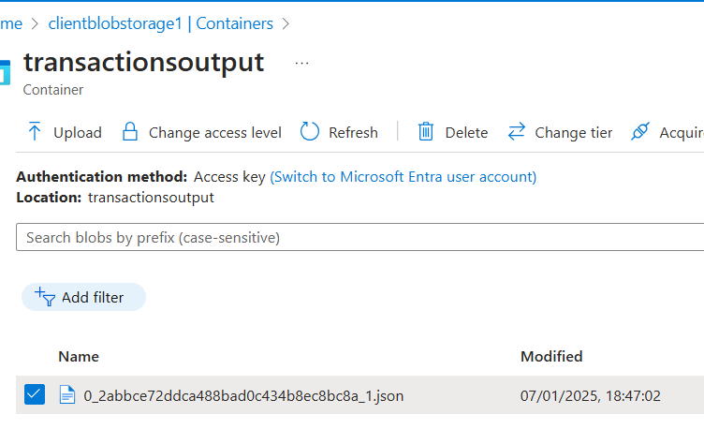

* Preview of output data:

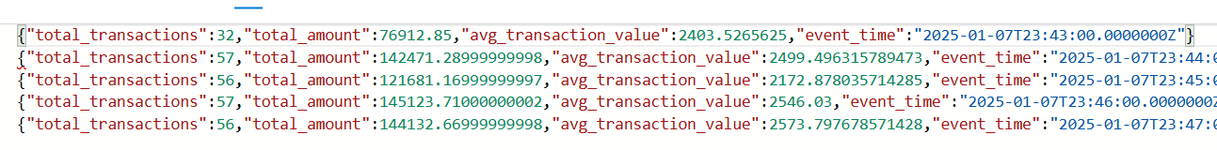

* Query 2: To detect fradulent activity in transactions data:

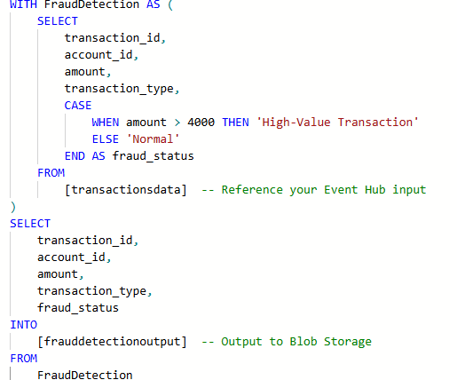

* Test the query and save it:

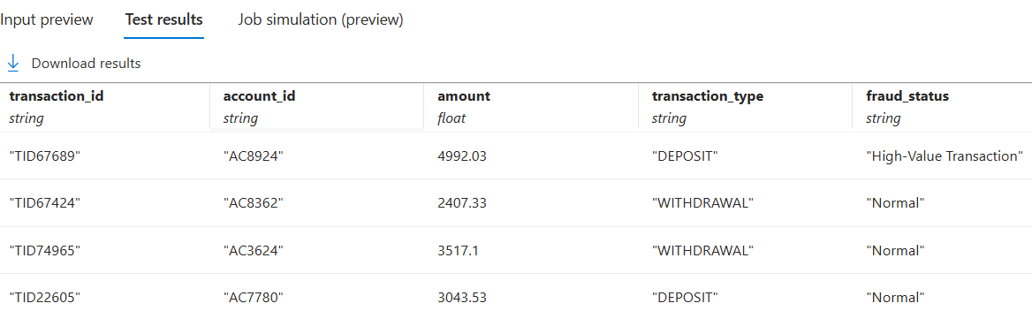

* Start the job: the event hub ingests the data, followed by stream analytics processing and loading the data into blob conatiner
* Data loaded into Containers:

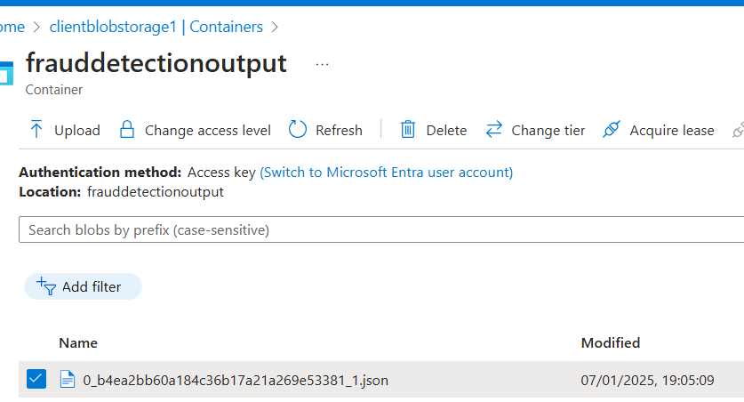

* Preview of output data:

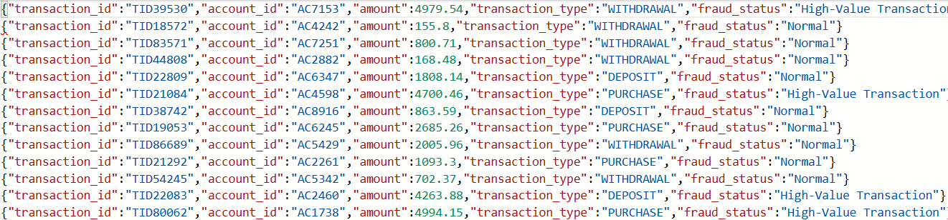

1. Set up Power BI dashboards to visualize the transactions data:

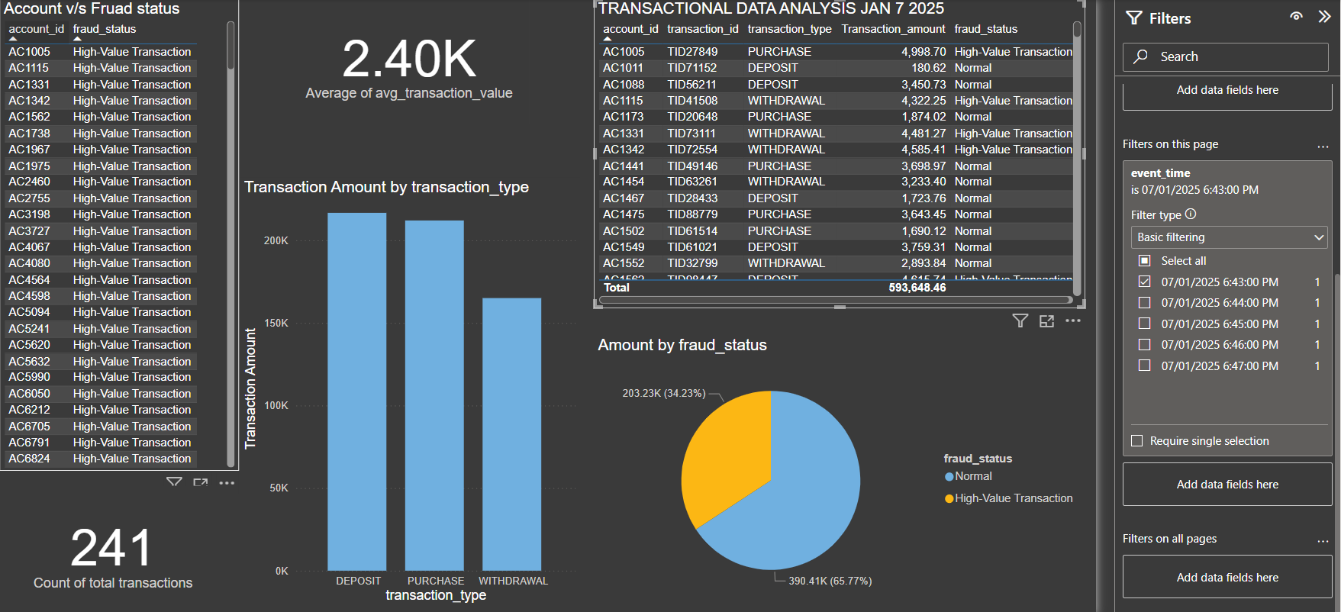

**Conclusion:**

The project successfully implemented a real-time financial transaction monitoring system using Azure services. Data was generated via Azure Event Hub SDK, ingested into Event Hub, processed in Azure Stream Analytics to detect fraud and calculate metrics, and stored in Azure Blob Storage. Power BI dashboards provided actionable insights, demonstrating Azure's scalability and reliability for real-time monitoring and decision-making in financial data processing.

This system demonstrates how Azure's scalable and reliable architecture can address real-world challenges in financial data processing, offering an effective solution for real-time monitoring and decision-making.